

**Dynamics 365 – New Part Creation**

**Revision 1**

**Revision History**

|  |  |  |  |  |
| --- | --- | --- | --- | --- |
| **Date** | **Revision** | **Description** | **Signature / Date** | |
| 25/03/2022 | 1 | Initial draft of user manual: New Part Creation | Prepared | Salman Tahir |
|  |  | Verified |  |
|  |  | Approved |  |
| 02/11/2022 | 2 | User manual: New Part Creation | Prepared | Waseem Abbas |
|  |  | Verified |  |
|  |  | Approved |  |
|  |  |  | Prepared |  |
|  |  |  |  |
|  |  |  |  |
|  |  |  |  |  |
|  |  |  |  |
|  |  |  |  |

**Table of Contents**

1 About User Manual 5

2 Dynamics 365 – Part Creation 5

2.1 Released Products 5

2.2 New Part 5

2.3 New Part Rev 6

List of Figures

Figure 1. Way to Open 'Released product' page 5

Figure 2. Select 'New Part' Option 5

Figure 3 Wrong ID format Item selection 6

Figure 4. Enter the details for New Part 6

Figure 5. Search the Item Number 7

Figure 6. Enter the desired rev 7

# About User Manual

This document describes the step-by-step guide for creation of New Part. It is process to add any part which is currently non-existing.

# Dynamics 365 – Part Creation

## Released Products

In order to create new part, select the modules option. Go to the Product Information Management and select released products available under the Products sub-option.

**Navigation**: Product Information Management > Products > Released Products

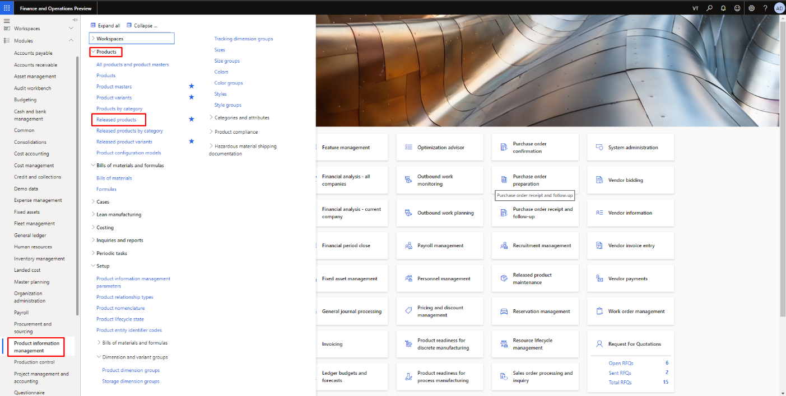

Figure 1. Way to Open 'Released product' page

## New Part

To create new part, select the ‘New Part’ option available on the top.

**Navigation**: Product Information Management > Products > Released Products > New Part

Then user need to fill the fields in the Create New Part form. The user needs to select the part Id format to select the item number. In the form, we have 3 types of Id format “[P/T] ######”, “V######” and “Custom”. The user can only use the item number as per its Id format.

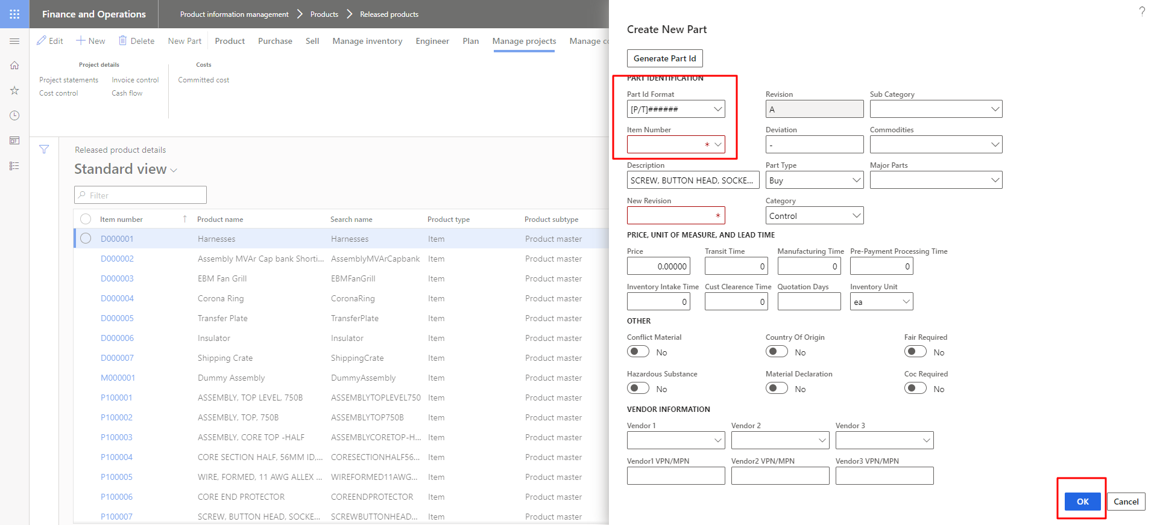

Figure 2. Select 'New Part' Option

The user will see the error message if the user selects different Id format and item number.

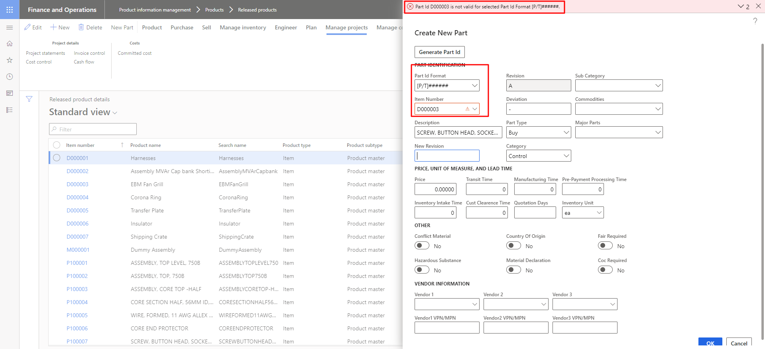

Figure 3 Wrong ID format Item selection

Enter the details for the new part and press the ‘**Ok’** button.

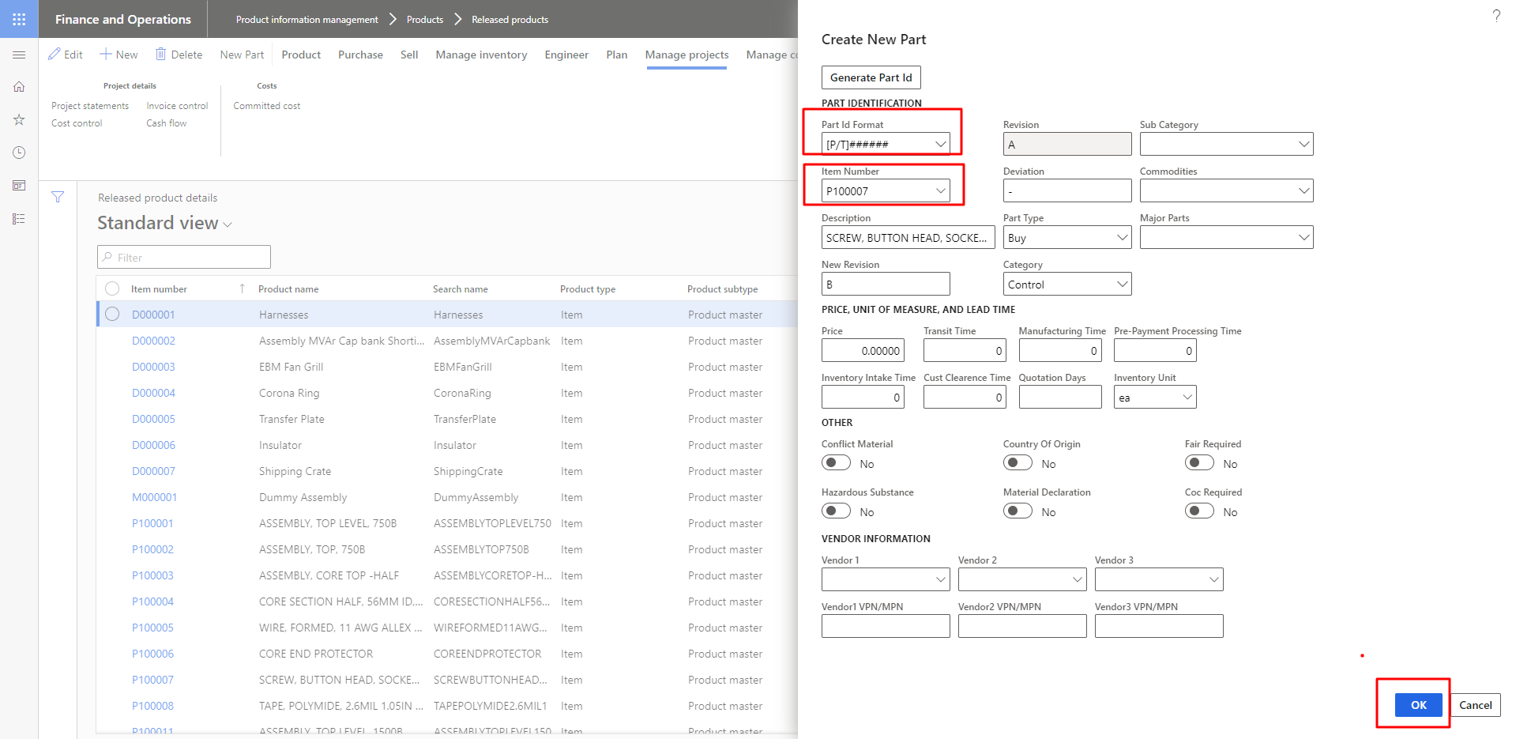

Figure 4. Enter the details for New Part

## New Part Rev

In order to add new ‘**Rev’** for any existing part, search the item number for which you want to add the new Rev.

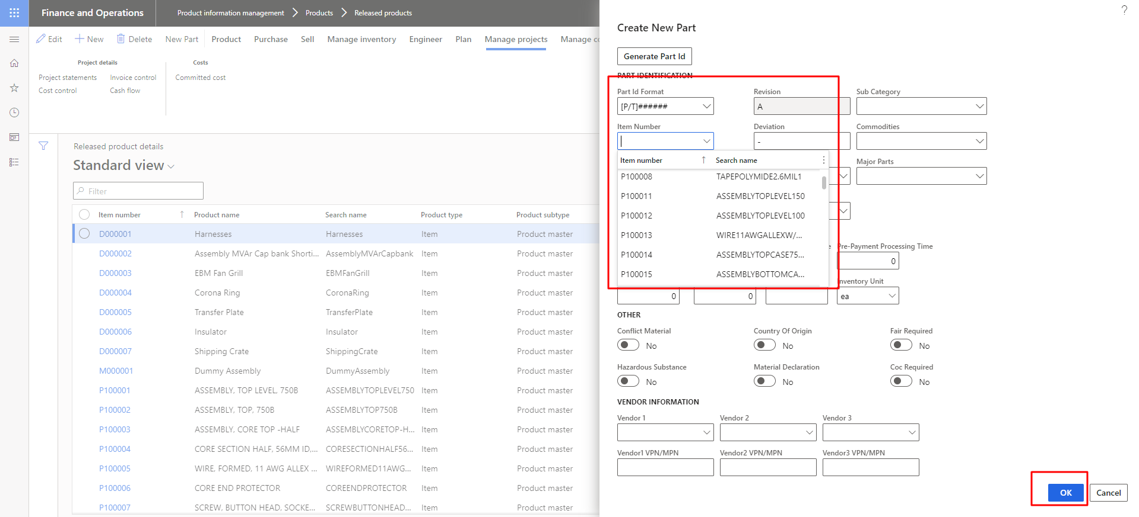

Figure 5. Search the Item Number

System suggests new Rev using existing Rev associated with selected part. Enter the details for the new Rev and press the ‘**Ok’** button.

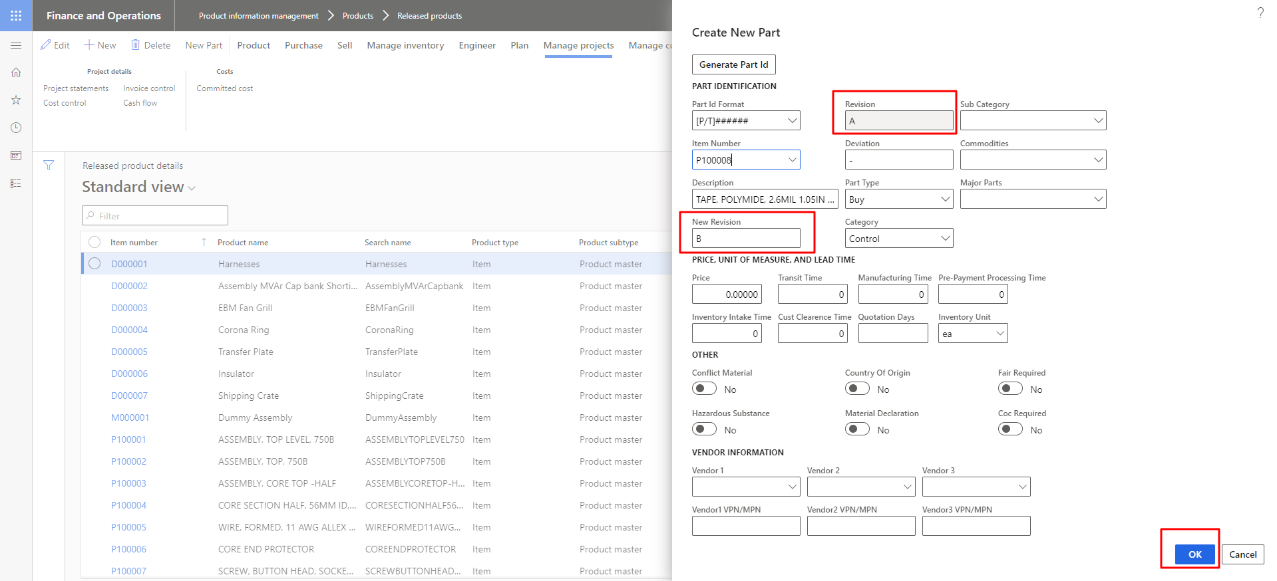

Figure 6. Enter the desired rev